NAT Builder - Overview

Translation Table – When you add the IPs they will first show up in here, you can then check the correct Inside is going to be translated to the correct outside
CSV Input – If you have used the VM builder script you can use the same CSV to build the NAT rules, select or past the path to the CSV here.

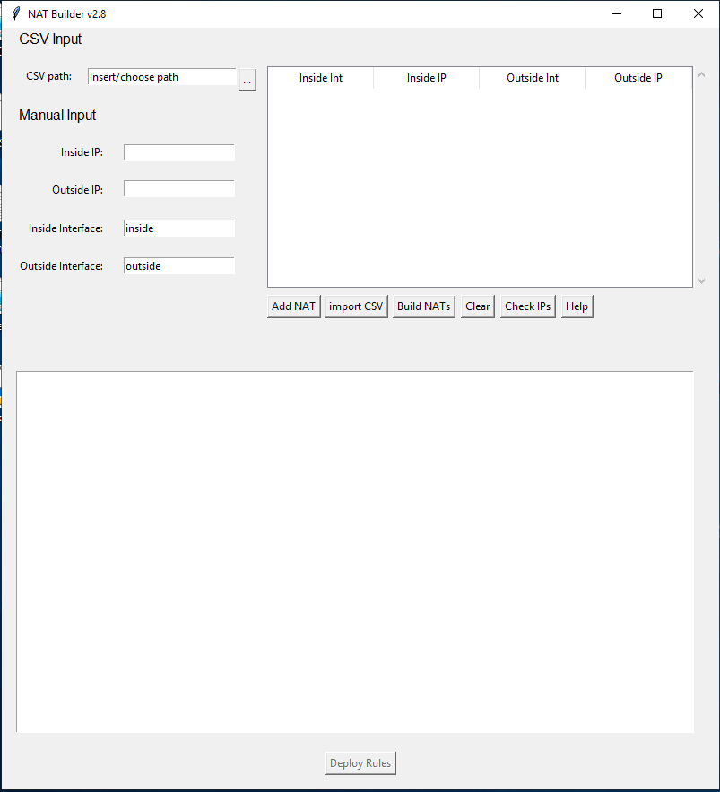
Manual Input – Manual input used to enter the IPs, either single IPs can be entered, or a range assume they are in the same /24 network
Deploy Rules – Button used to deploy the NAT config to the firewall, will only be available when ‘Check IPs’ has been run.
Output Box – This box is where the output of any commands run will appear such as ‘Build NATs’ and ‘Check IPs’.
Add NAT – Button to add NAT rules when you have filled in the Manual Input boxes.
Import CSV – Button used to input the CSV file you have put in the CSV path box.
Build NATs – Used to build the config based on the IPs you have imported
Clear – Clears the IPs out the table.
Check IPs – Used to run the checks for the IPs in the table against a firewall.
Help – Gives access to quick help

NAT Builder – Navigating the App
This will guide you through the process of entering the IPs to deploying the config onto the firewall. Note that you do not have to follow this exact path, the mandatory part is to enter the IPs but from here you can either run checks or build the config if that’s all you need to do. There is no requirement to deploy to the firewall at the end.
- Entering the IPs
The two options you have for entering IPs are:
CSV Input
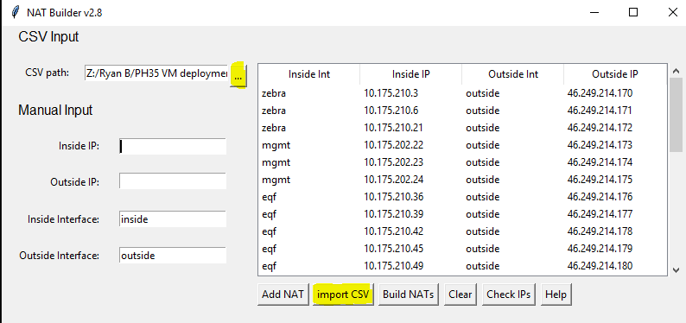
To import IPs into the Translation table via CSV, you will need to either select the CSV from file explorer which can be done using the 3 dots or paste the path to the CSV into the ‘CSV path’ field. You can then click ‘Import CSV’.
Manual Input
Manual input is most likely what you will be using as the VM build script needs reviewing and most of the time we are only building a couple of VMs. To enter IPs manually you can either do it one by one or by a range assuming that the IPs are in the same /24 subnet.
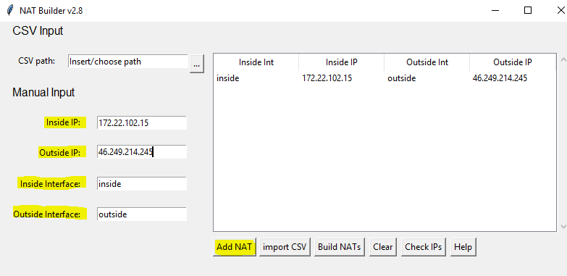
Above is an example of adding a single NAT, to do this you will need to do the following under Manual Input:
- Enter Inside IP as allocated in Mist
- Enter Outside IP as allocated in Mist
- Default inside interface is set to inside, change this if necessary
- Default Outside interface is set to outside, change this if necessary
Once you have filled out the fields under ‘Manual Input’ you can then click ‘Add NAT’ which adds the NAT into the Translation Table. You can then repeat the above steps for each of the NATs you need to add.
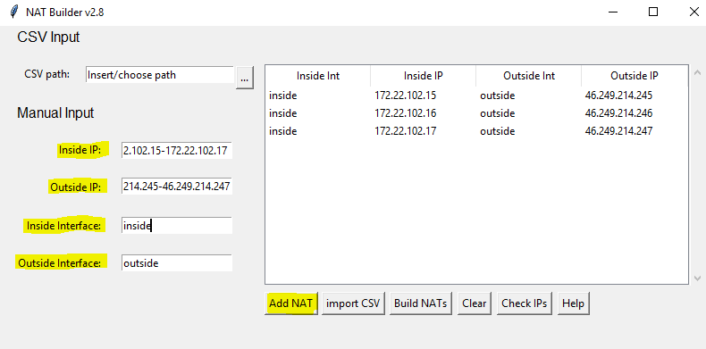
Above is an example of adding a range, to add a range the requirements are:
- The IPs must be in the same /24 network, for example, 172.22.102.15-172.22.102.17
- The number of IPs in the inside IP range and Outside IP range must match.
- The IPs for the start and end of the range must contain all octets, for example, you cannot do 172.22.102.15-17
To enter a range of IPs you need to:
- Enter your range of inside IPs in the ‘Inside IP’ field
- Enter your Range of Outside IPs in the ‘Outside IP’ field
- Default inside interface is set to inside, change this if necessary
- Default Outside interface is set to outside, change this if necessary
Once you have filled in the fields under the ‘Manual Input’ you can then click the ‘Add NAT’ button which will populate the Translation table mapping the first Inside IP to the first Outside IP and so on.
- Check IPs

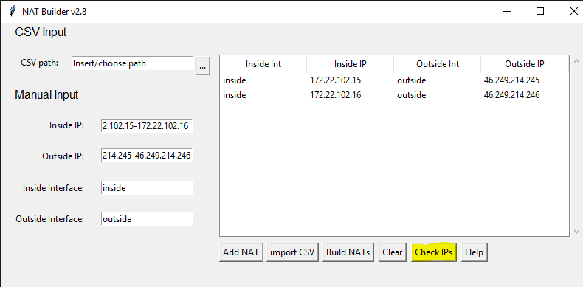
After populating the Translation table with the NAT rules that you require, you can then check the IPs against the firewall to make sure they are free. To do this first click the ‘Check IPs’ button.
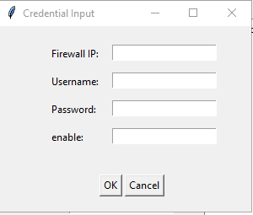
This will then bring up a PopOut box which will prompt you for the Firewall IP, username, password, and enable password. You must fill in all these fields even if the login password and enable password are the same.

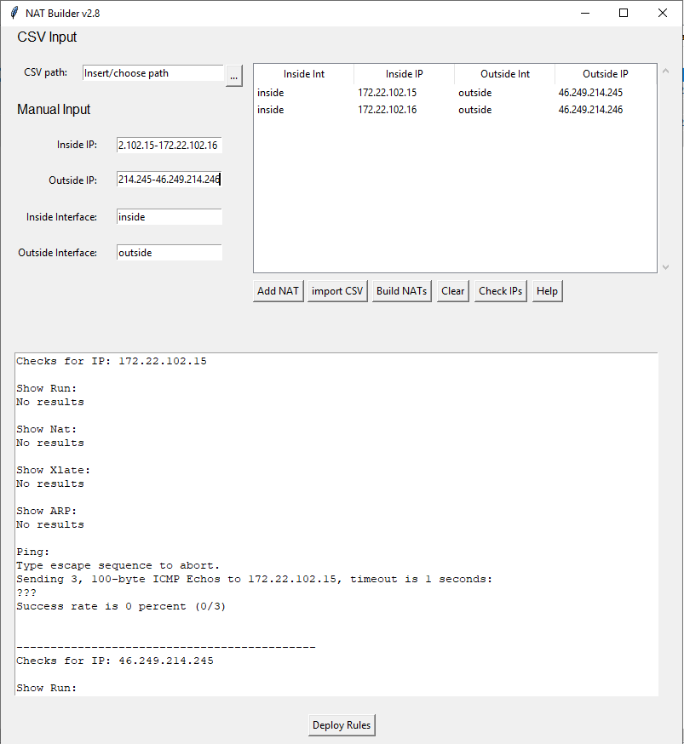
Once you click OK on the PopOut box, it will run the checks and print the results into the Outbox Box. It is up to you as the user to read through these checks to make sure you are happy to proceed with the deployment. If you are not happy with the results do not proceed to deploy, the ‘Deploy Rules’ button will become available no matter what after running the checks and should not be used as an indication that it is safe to do so.

- Build NATs
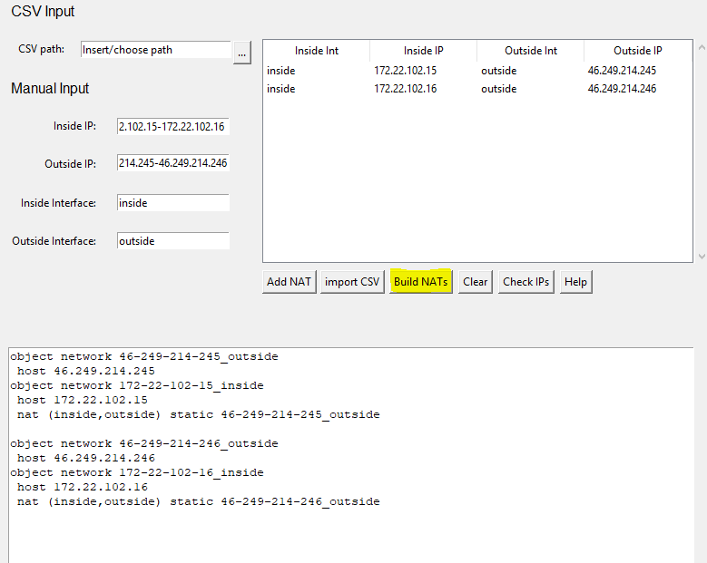
Once you have checked the IPs against the firewall or populated the Translation table you can build the config based on the IPs by clicking the ‘Build NATs’ button. This will print the config to the Output Box where you can either copy it or proceed to Deploy Rules.
- Deploy Rules

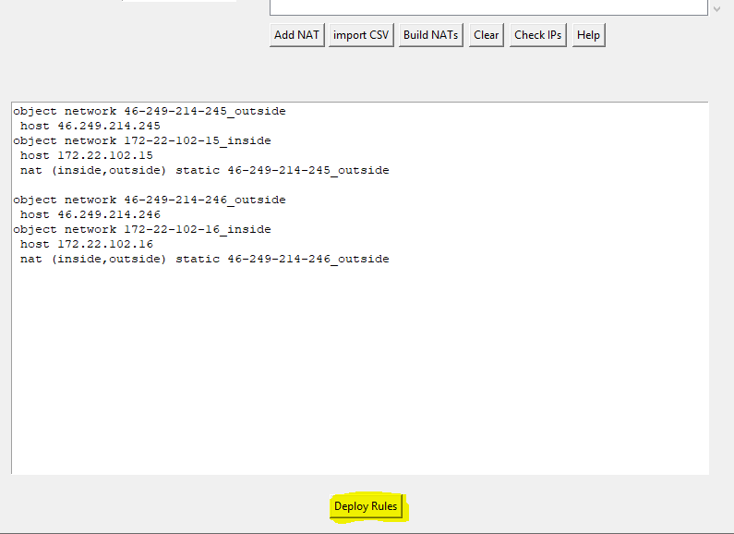
Once you have checked the IPs against the firewall and built the NAT config you will then be able to deploy the rules to the firewall. To do this click the ‘Deploy Rules’ button at the bottom.

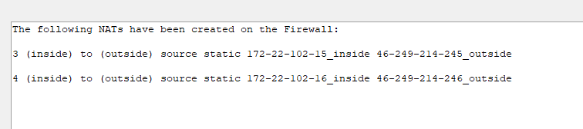
When you click the ‘Deploy Rules’ button it will deploy the rules and then run a check to make sure that the NAT rules have been applied successfully, if this is the case it will return the NAT rules in the Output box. You can also check on the firewall.

